Grant BBQ Festival Marketplace Rules
April 14, 15, 16 2023
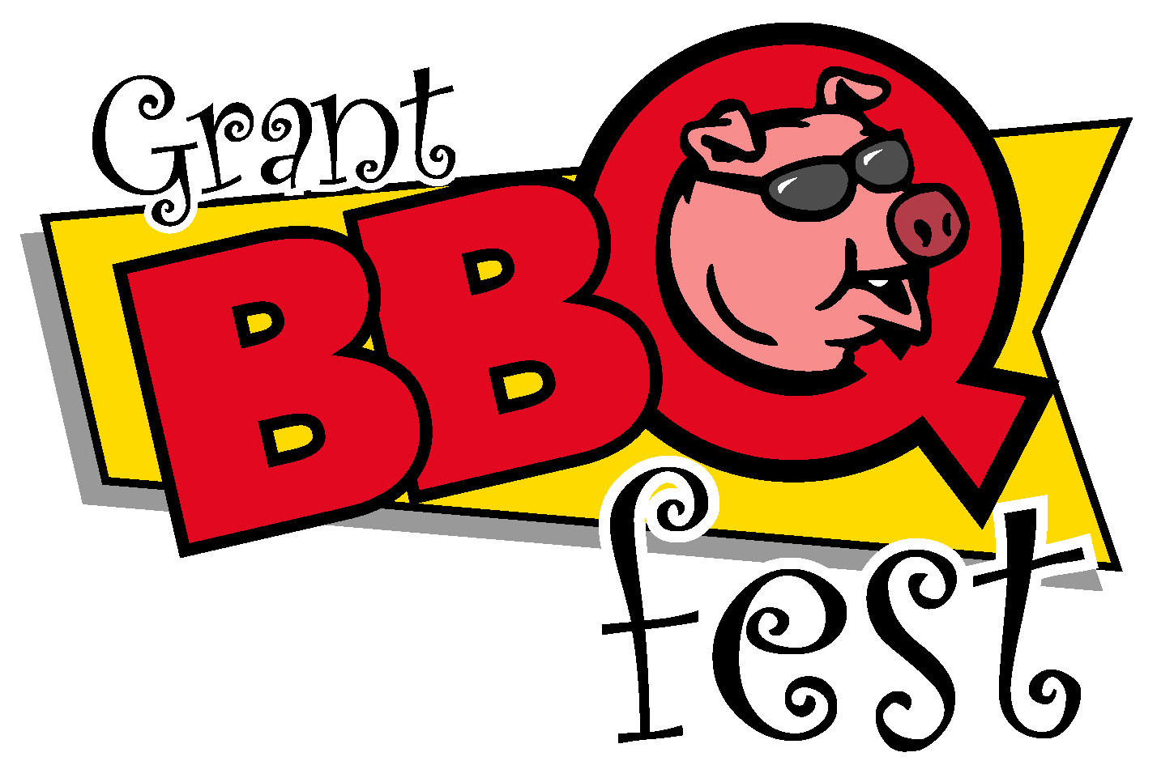
- You must submit the following: Completed application, photos of your craft/merchandise (if 1st time attendee), check or money order, payable to “Toys for Kids” or through our pay pal account.
- Each space is 10 x 10. Rates are $150 for Friday, Saturday, and Sunday. No partial registration. If you need more than one space please specify on your application, also include any requests on application. You are then assigned a spot. Spots WILL NOT be changed on the day of check in.
- Your canopy or tent must have a national fire retardant label per county regulations. You may want to bring ant bait and bug spray as all spaces are outdoors in a grassy area. Come prepared for all kinds of weather.
- Pornography is strictly prohibited.
- NO electricity is provided in vendor area. Quiet generators are allowed. Cords may not run across aisles. NO RV hookups are available, but parking is available.
- Marketplace vendors will not sell drinks. Any food item must be listed on application and pre-approved before event.
- Exhibitor space must be manned at all times. Children are not to be left unattended. Pets are NOT allowed on the grounds at any time. All exhibitor trash and items must be removed.
- The show will be open Friday from 3pm to 8pm, Saturday from 10am to 8pm, and Sunday from 10am to 5pm. Check in and set up will be allowed on Friday beginning at 9 am and on Saturday beginning at 7am. A free parking area for vendors is designated. All vehicles must be off the grounds 1 hour prior to the festival opening.
- All property taken onto the “Grant BBQ Fest” grounds by the exhibitor is taken at the exhibitor’s own risk. The “Grant BBQ Fest” shall NOT be responsible for any loss or damage resulting from fire, theft, wind, or any other cause, nor failure upon its part to perform this agreement should officers of the law seize, stop, or prevent the exhibitor from operating under this contract.
- The exhibitor agrees to release, defend, indemnify, and save harmless the “Grant BBQ Fest” from and against any and all loss, cost, expense, and claims for damages and injuries including death to persons or property resulting from acts or omissions of exhibitor, its agents, or employees.
- The “Grant BBQ Fest” reserves the right to cancel this agreement at any time, for any reason deemed necessary. Any exhibitor violating any of these rules will be asked to leave without refund of entry fee. The “Grant BBQ Fest” reserves the right to re-sell assigned spaces after 10:00am on Saturday morning of the festival.
- Application deadline is three days before the start of the event. No refunds. No exceptions. We will contact you by phone or email as soon as practical upon receipt of your application.
Additional applications are available at our website: www.GrantBBQFest.com
For any addition information, contact:
Kim Hewatt 321-591-1738/text preferred
email: artsandcraftersbbqfest@gmail.com

