Grant BBQ Fest Marketplace
April 14, 15, 16 2023
Grant Community Center
4580 First Street
Grant, FL 32949
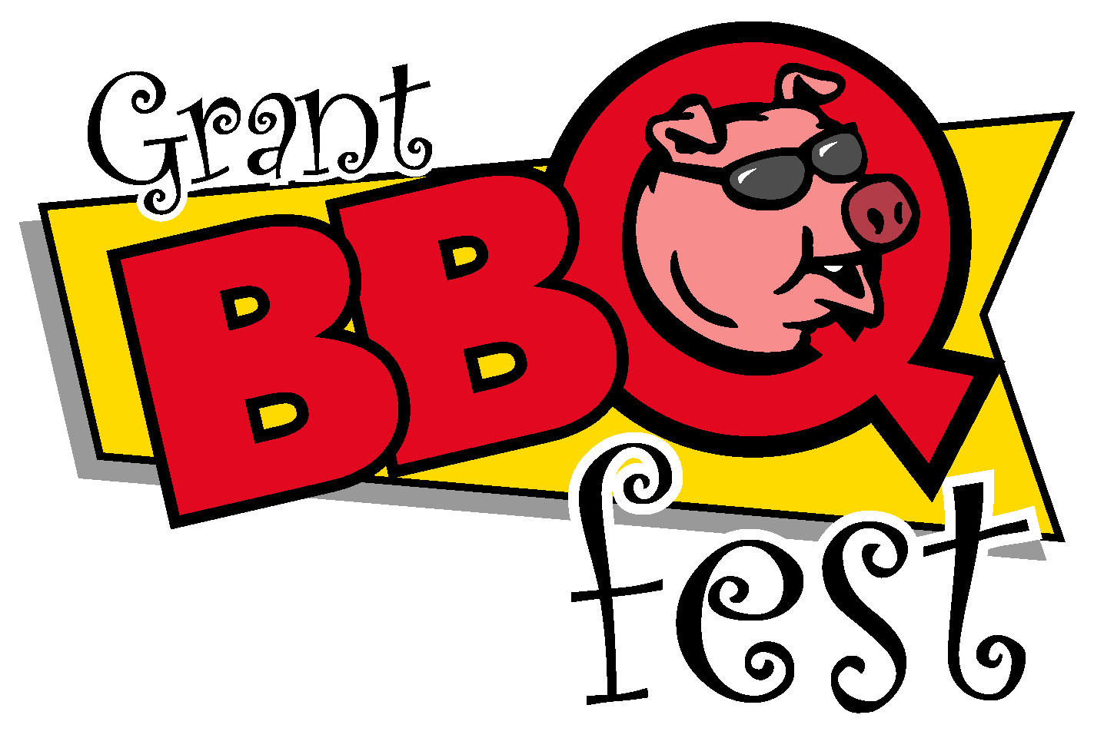

Name: ____________________________________________________________
Address: _ ________________________________________________________
__________________________________ __________________ ________
Phone: __________ __________________________________________________
Email: ___________ _________________________________________________
Florida Tax Id: __________________ __________________________________________
Type of Art – Craft – Merchandise (circle all that apply) Paintings – Graphics – Photography –
Ceramics Pottery – Wood – Leather – Glass – Jewelry –Other (explain)
Craft: _______________________ _____________________________________
Merchandise: ___________________ ______________________________
Number of Spaces Requested: ___________ (Spaces are 10 x 10 each)
Special requests: _____________________________________________________________
Rates per space:
$150 – Friday 3p-8p, Saturday 10a-8p, Sunday 10a-5p
I hereby understand and agree to all rules of the “Grant BBQ Fest” Marketplace and that I will NOT have any merchandise with the “Grant BBQ Fest” marketing logo. Sales are not guaranteed.
Signature: __________________________________ Date: _________________
FOR OFFICIAL USE ONLY
Paid $________ Cash/Check/ Visa/Pay Pal: _________ # of Spaces Requested: _________
Date Received: _______________ _ By: ___________________________ _

Make checks payable to: ‘Toys for Kids’
Mail application & check to: 671 Anita Drive, Melbourne, FL 32935
Additional Information: Kim Hewatt Phone: 321-591-1738
email: artsandcraftersbbqfest@gmail.com

